Broadcast Journalism and Extemporaneous Speaking
Draw Procedures
ALL students entered in BJ and EXT will perform draw via SpeechWire even if they choose to prep their speech in the in-person prep room. No paper topic slips will be provided in-person. Please familiarize yourself with the following procedures and polices regarding draw an prep.
Prep Room Options
On-site Prep Room: MA-142
Virtual Prep Room: https://ucincinnati.zoom.us/j/8057333763
**Please mute yourself when entering the virtual draw space and remain on mute unless you need to communicate directly with Tournament Staff**
Tournament staff will make the announcement for speakers in both spaces when it is their time to draw.
Double Entry Bumps
Tournament Staff have been provided a list of all students double entered and have made the necessary adjustments to the draw order so there is no need to alert them of your status as Double Entered.
SpeechWire Accounts
To access draw via SpeechWire all students much have individual accounts. Coaches, make sure all competitors have SpeechWire accounts – these should be created by the coach and not independently by the student in the SpeechWire system.

View the step-by-step video here: Click on Student Accounts video.
https://www.speechwire.com/p-video-resources.php
Also provided is a pdf:
https://www.speechwire.com/handbooks/registrationhandbook.pdf
Electronic Draw Instructions
- Enter either the in-person or virtual prep room 5 minutes prior to the start of Draw for your speaker position. Members of the Tournament Staff will conduct a roll call to see who is present.
- Wait for your name to be called by the tournament staff – after all speakers at the designated speaker position are accounted for the draw manager will open draw for you.
- From your SpeechWire account click “Pi Kappa Delta – Biennial Tournament and Convention” and then “Click here to enter draw”
- You will then see any available topic draws listed for you. Select “Click here to draw now” for the corresponding round.
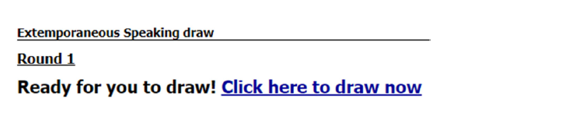
- For Extemp: select your question from the list provided. *You must CLICK your selected prompt*
- For Broadcast Journalism: You will be provided a list of three topic areas such as “Central America, the US Congress and Climate Change.” While other stories can be included to make time, judging criteria will favor those identified in the round’s prompt.
